Orphanage Database

ER Diagram:

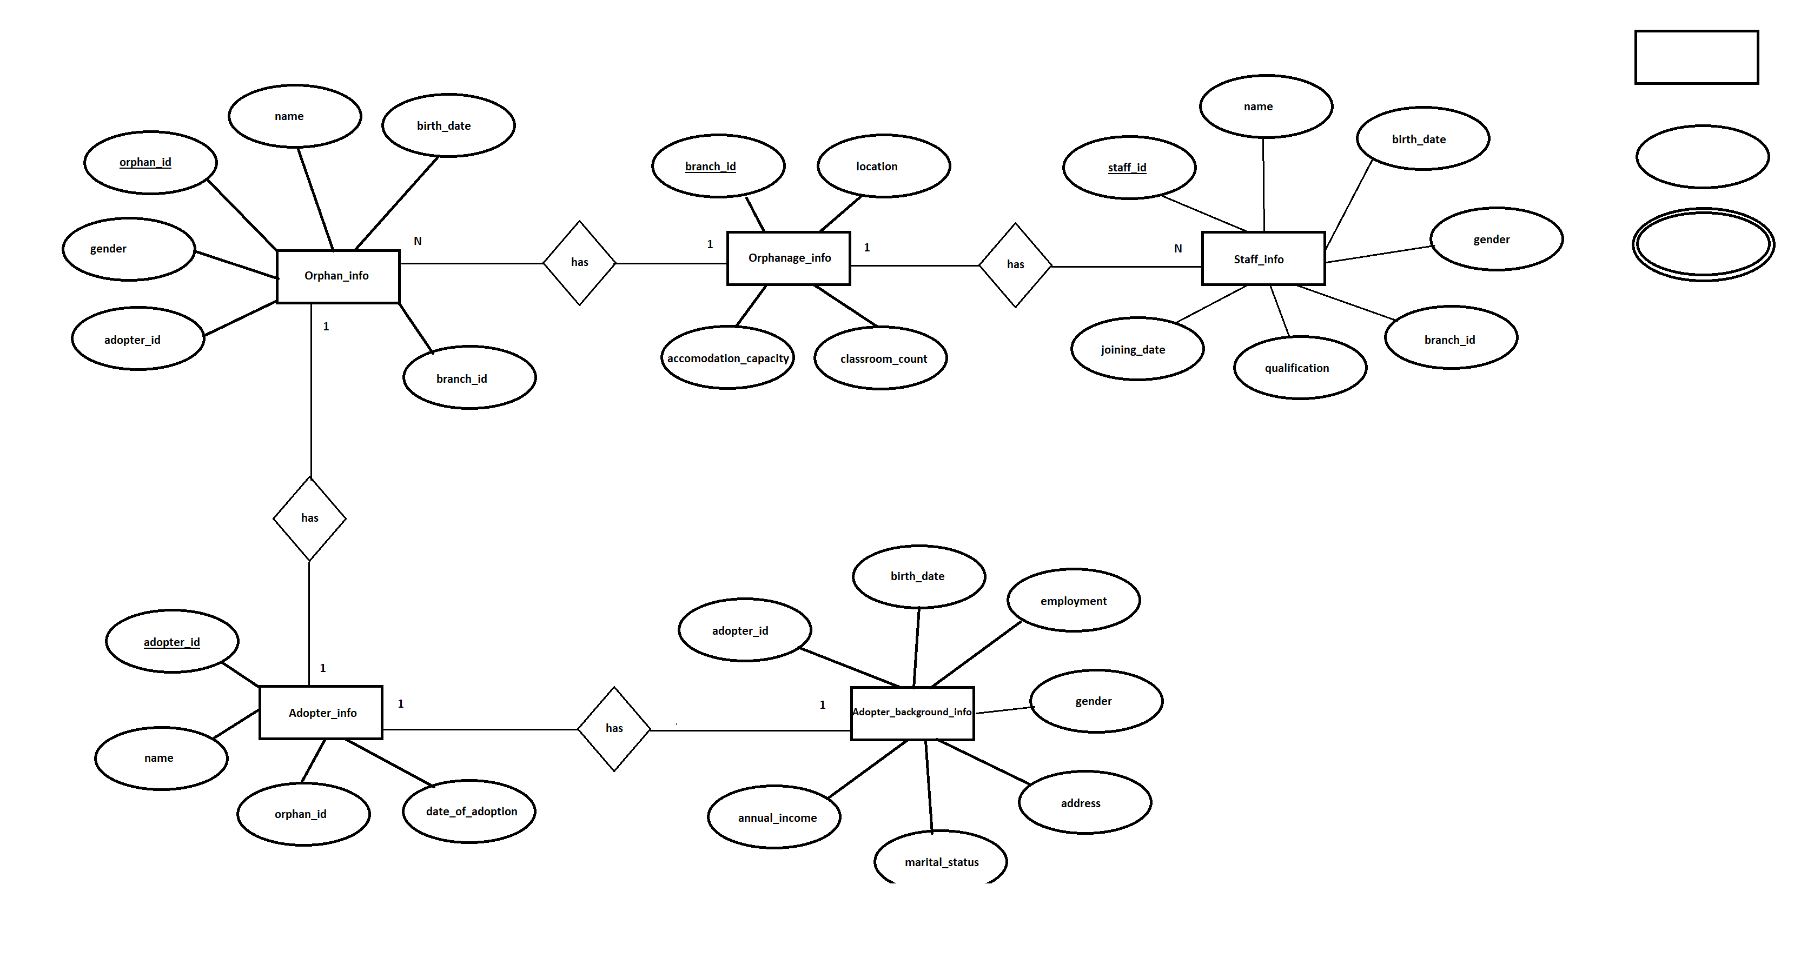

Table Schemas

Orphanage_info:

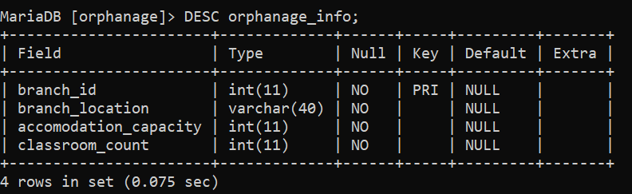
Orphan_info:

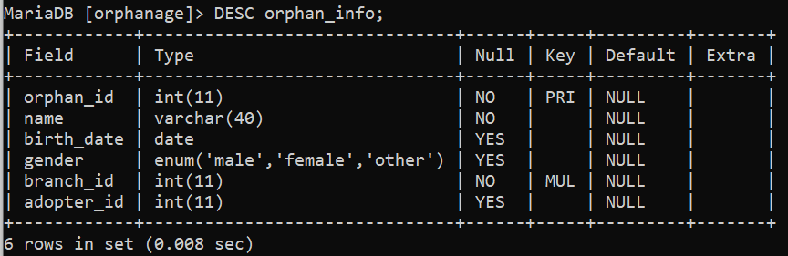
Staff_info:

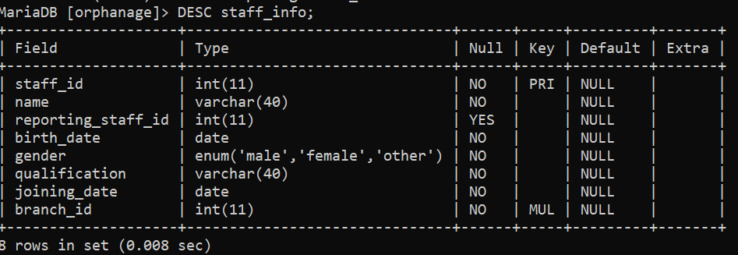

Adopter_info:

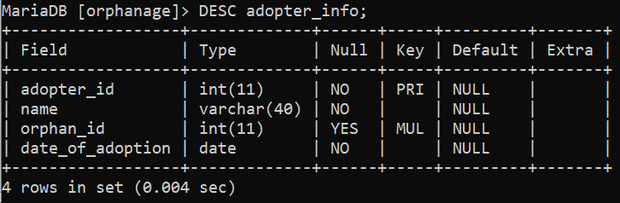

Adopter_background_info:

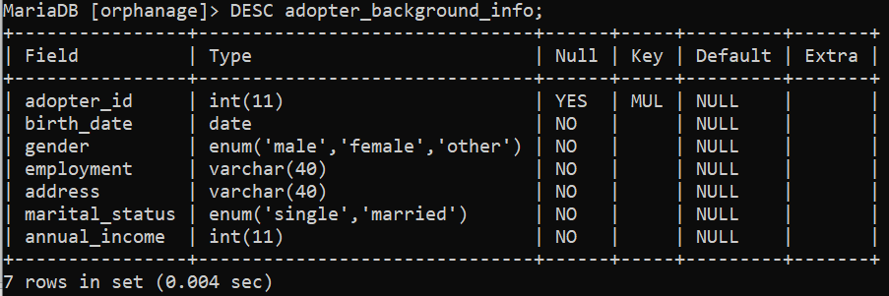

Tables

MariaDB [orphanage]> SELECT * FROM orphanage_info;
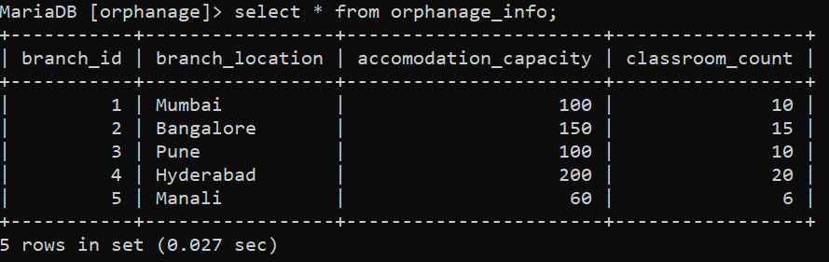
MariaDB [orphanage]> SELECT * FROM staff_info;

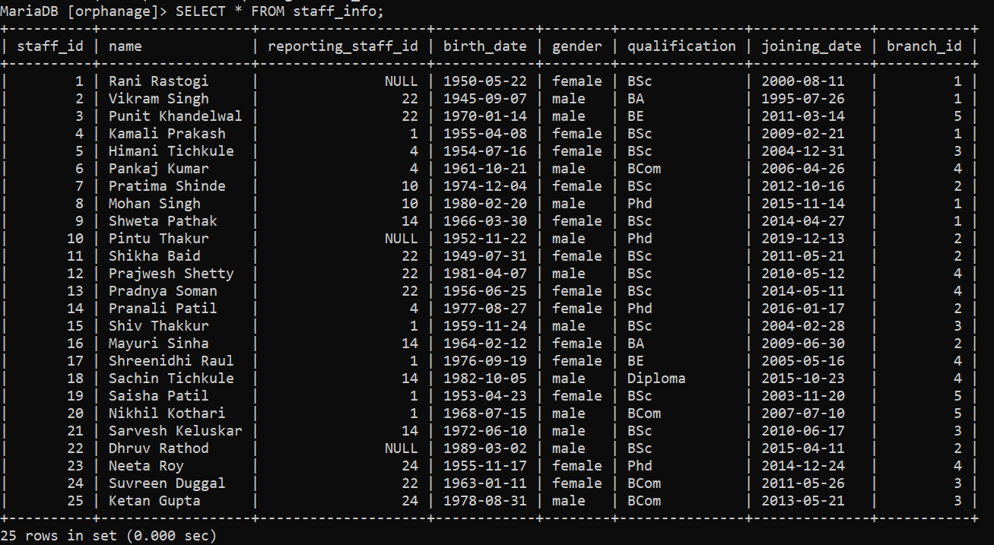
MariaDB [orphanage]> SELECT * FROM orphan_info;
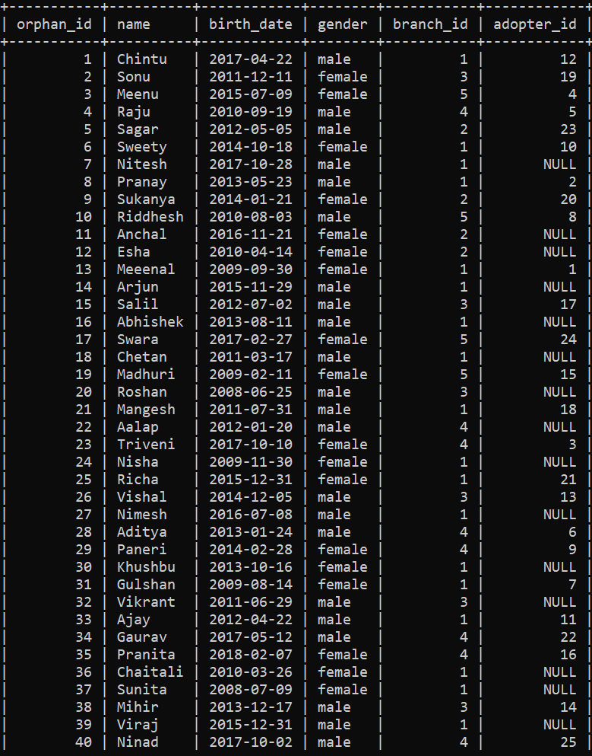

MariaDB [orphanage]> SELECT * FROM adopter_info;

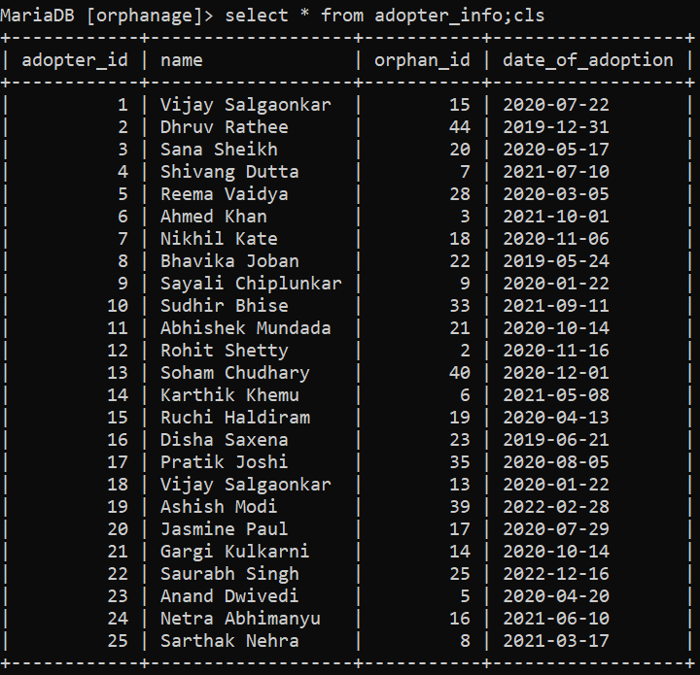
MariaDB [orphanage]> SELECT * FROM adopter_background_info;

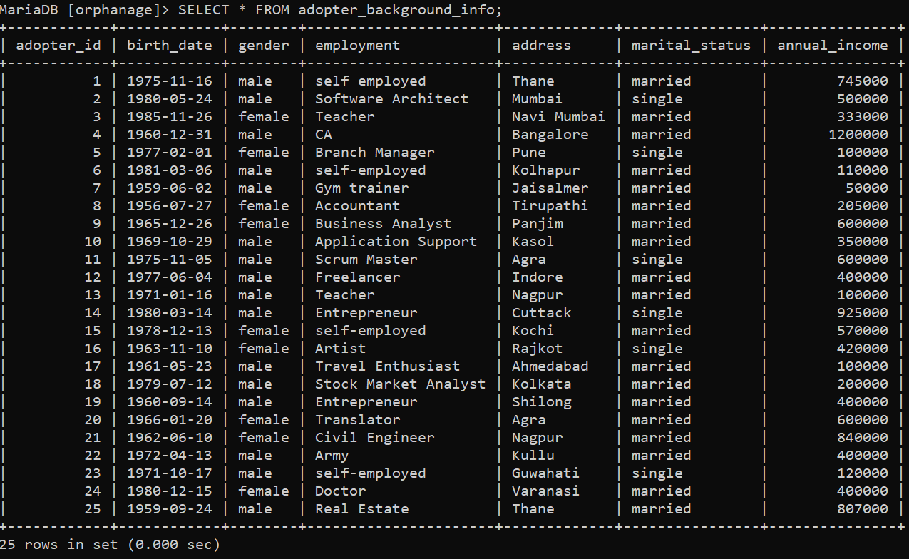

Subqueries

1. Details of branch from which Karthik Khemu adopted a child?

MariaDB [orphanage]> SELECT * FROM orphanage_info WHERE branch_id = (SELECT branch_id FROM orphan_info WHERE orphan_id = (SELECT orphan_id FROM adopter_info WHERE name = 'Karthik Khemu'));
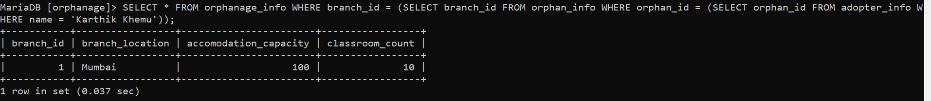

2. Details of children adopted by single males and single females.

MariaDB [orphanage]> SELECT * FROM orphan_info WHERE adopter_id IN (SELECT adopter_id FROM adopter_background_info WHERE marital_status = 'single') ORDER BY adopter_id;
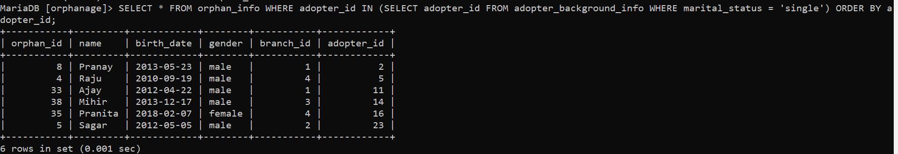
3. Find the branch with maximum non adopted children.

MariaDB [orphanage]> SELECT branch, count_nonadopted FROM (
(SELECT branch_id AS branch, COUNT(orphan_id) AS count_nonadopted FROM orphan_info WHERE adopter_id IS NULL GROUP BY branch_id ORDER BY count_nonadopted DESC)
AS max_count_nonadopted) LIMIT 0,1;

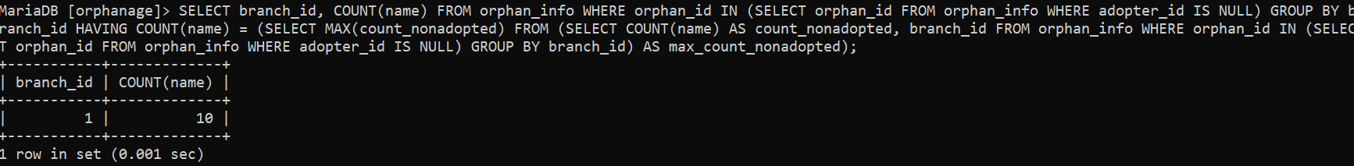

Joins

1. Display details from orphan_info and adopter_background_info with respect to adopter_id

MariaDB [orphanage]> SELECT * FROM orphan_info INNER JOIN adopter_background_info ON orphan_info.adopter_id = adopter_background_info.adopter_id;

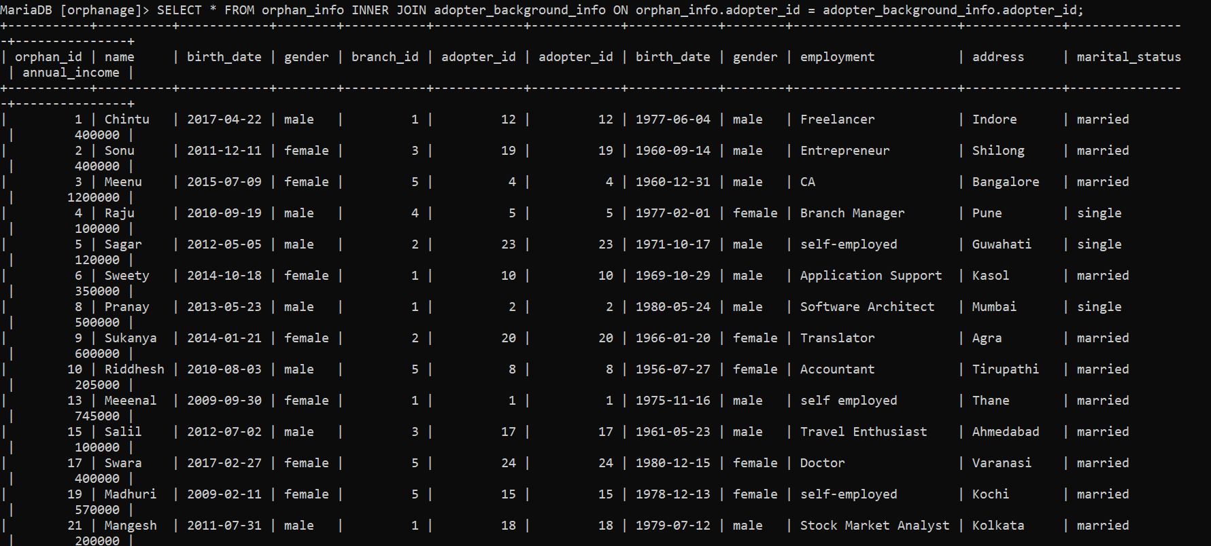

2. Show branch wise details of all children

MariaDB [orphanage]> SELECT * FROM orphanage_info LEFT JOIN orphan_info ON orphanage_info.branch_id = orphan_info.branch_id ORDER BY orphanage_info.branch_id;

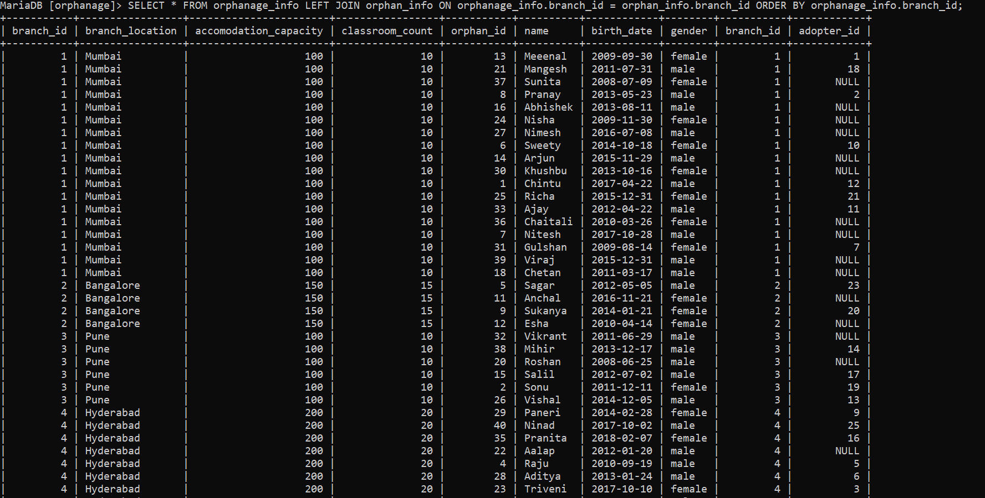

3. Display the staff persons names along with the names of those whom they report to.

MariaDB [orphanage]> SELECT s2.name AS staff, s1.name AS reporting_staff FROM staff_info s1 JOIN staff_info s2 ON s1.staff_id = s2.reporting_staff_id;

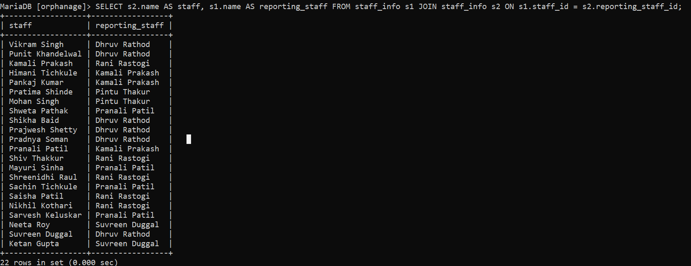
Views

1. Create a view to show only names of adopters and the child whom they adopted.

MariaDB [orphanage]> CREATE VIEW v2 AS SELECT orphan_info.name AS Child_Name, adopter_info.name AS Adopter_Name FROM orphan_info, adopter_info WHERE orphan_info.orphan_id = adopter_info.orphan_id;
Query OK, 0 rows affected (0.190 sec)

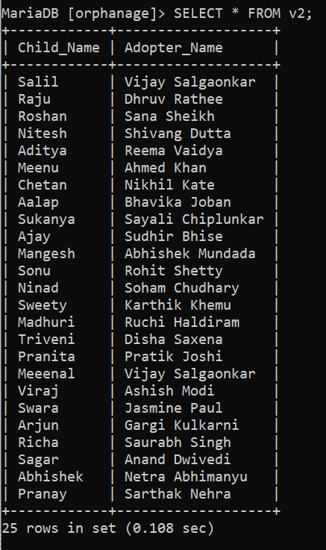

Date of adoption of child xyz.

List of single male adopters

List of single female adopters

Age of adopters

Adopter adopted the child from which branch?

MariaDB [orphanage]> SELECT branch_id, COUNT(name) FROM orphan_info WHERE orphan_id IN
(SELECT orphan_id FROM orphan_info WHERE adopter_id IS NULL) GROUP BY branch_id HAVING COUNT(name) =
(SELECT MAX(count_nonadopted) FROM
(SELECT COUNT(name) AS count_nonadopted, branch_id FROM orphan_info WHERE orphan_id IN
(SELECT orphan_id FROM orphan_info WHERE adopter_id IS NULL) GROUP BY branch_id) AS max_count_nonadopted);

MariaDB [orphanage]> SELECT branch_id FROM orphan_info WHERE adopter_id IS NULL GROUP BY branch_id HAVING COUNT(orphan_id) =
(SELECT MAX(count_nonadopted) FROM (SELECT COUNT(orphan_id) AS count_nonadopted FROM orphan_info WHERE adopter_id IS NULL GROUP BY branch_id) AS max_count_nonadopted);

SELECT branch_id AS branch, COUNT(orphan_id) AS count_nonadopted FROM orphan_info WHERE adopter_id IS NULL GROUP BY branch_id ORDER BY count_nonadopted DESC LIMIT 0,1;

